Using sed utility
1- Display the lines that contain the word “lp” in /etc/passwd file.
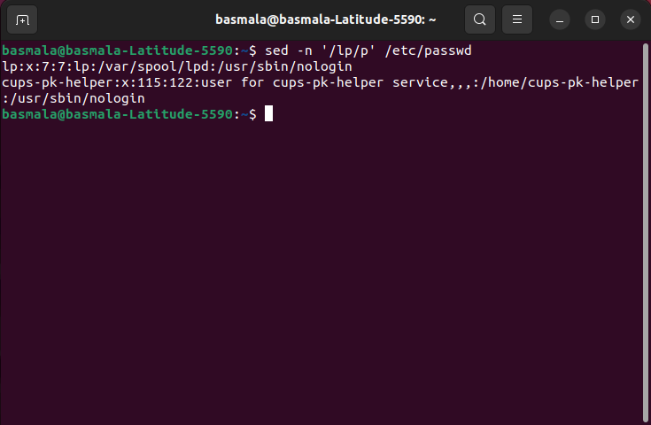
2- Display /etc/passwd file except the third line.
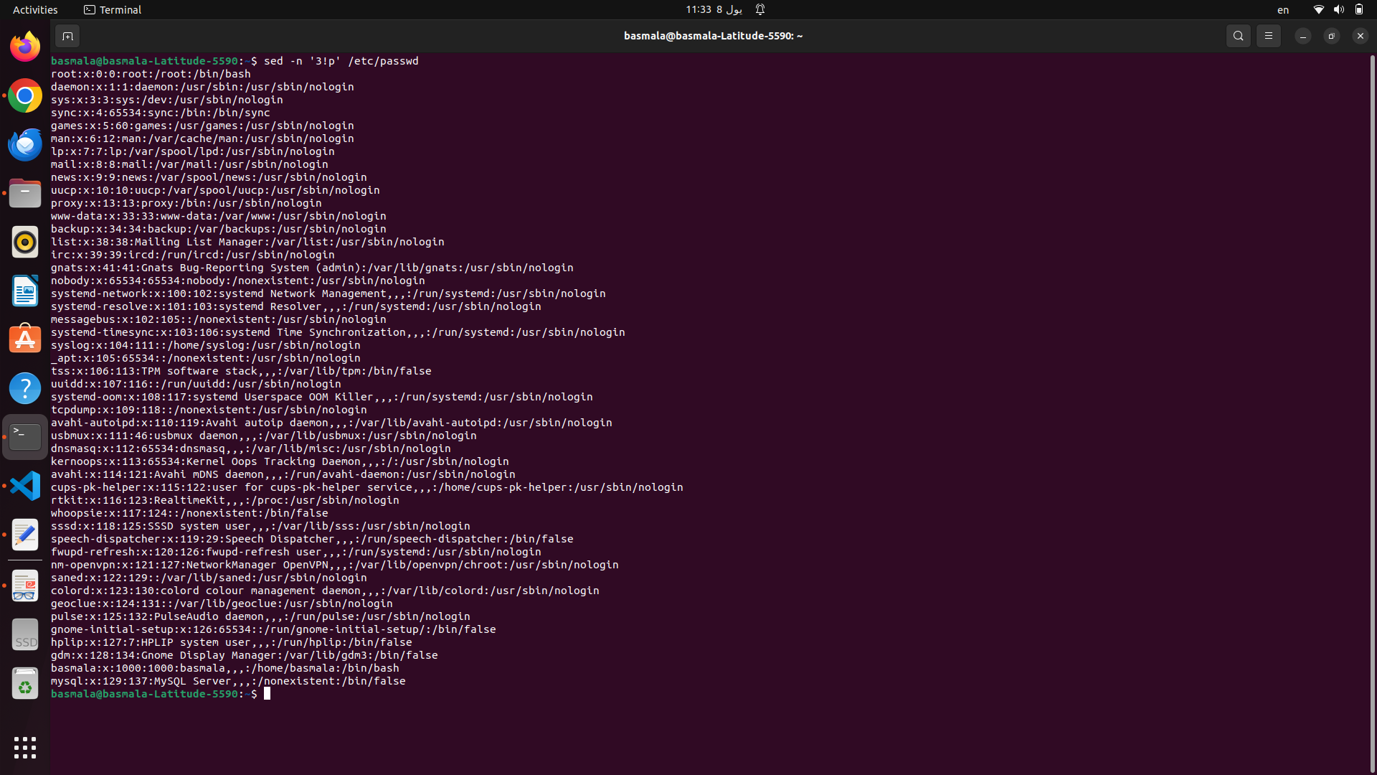
3- Display /etc/passwd file except the last line.
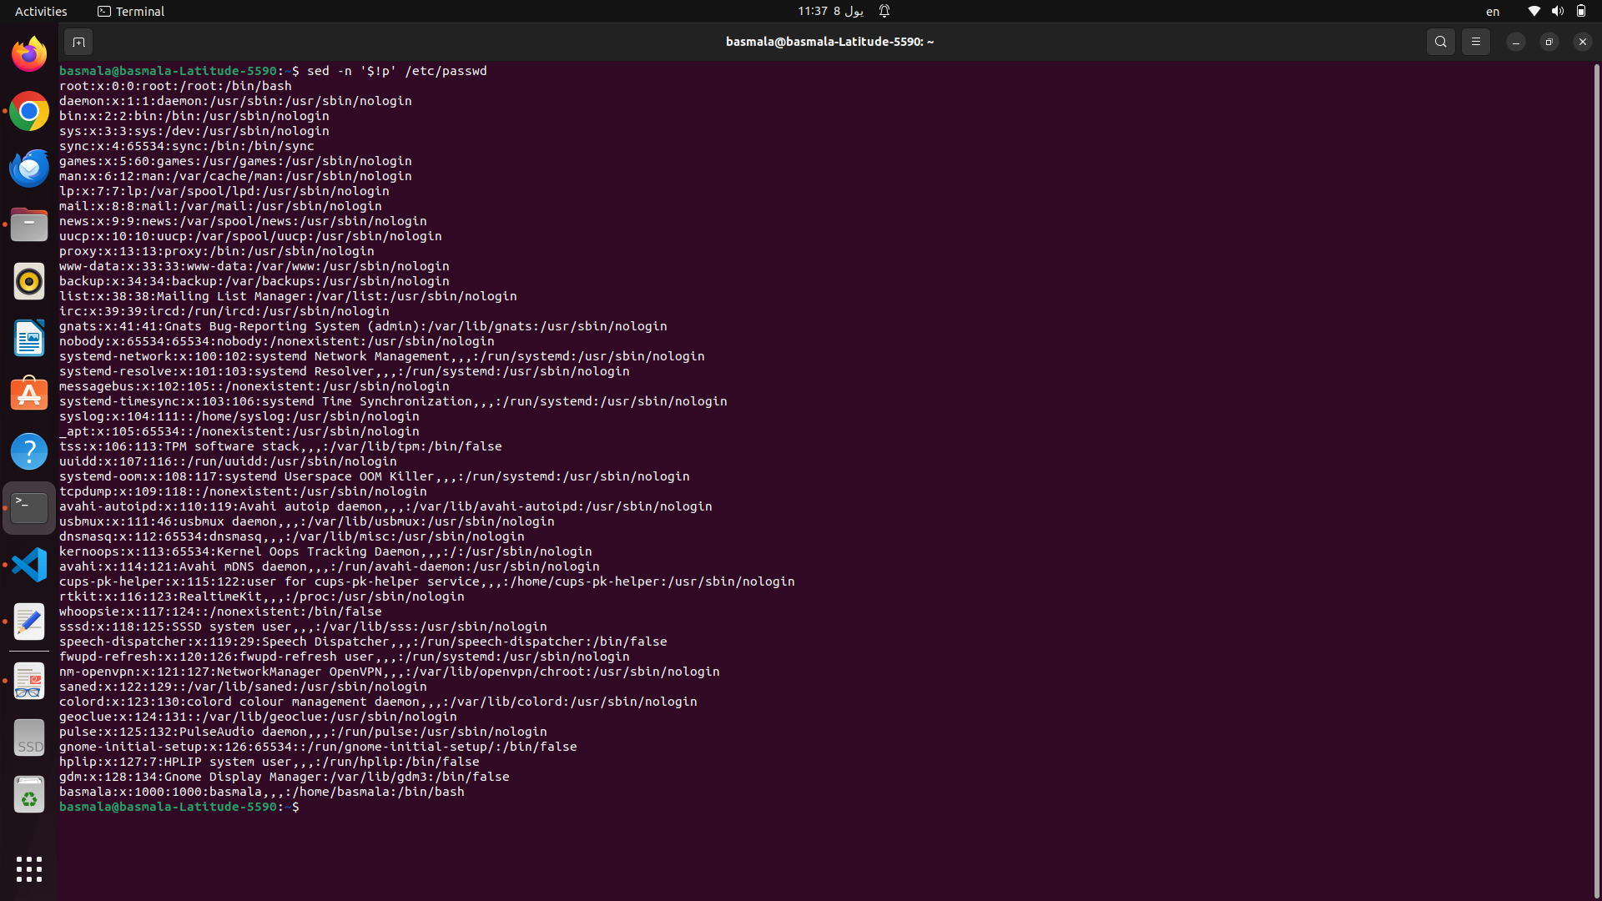
4- Display /etc/passwd file except the lines that contain the word “lp”.
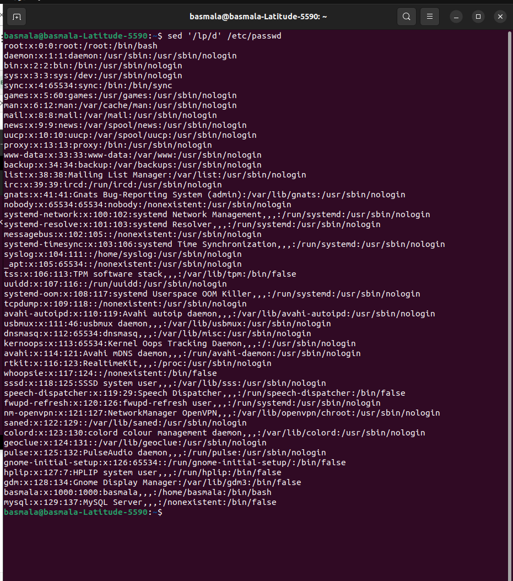
5- Substitute all the words that contain “lp” with “mylp” in /etc/passwd file.
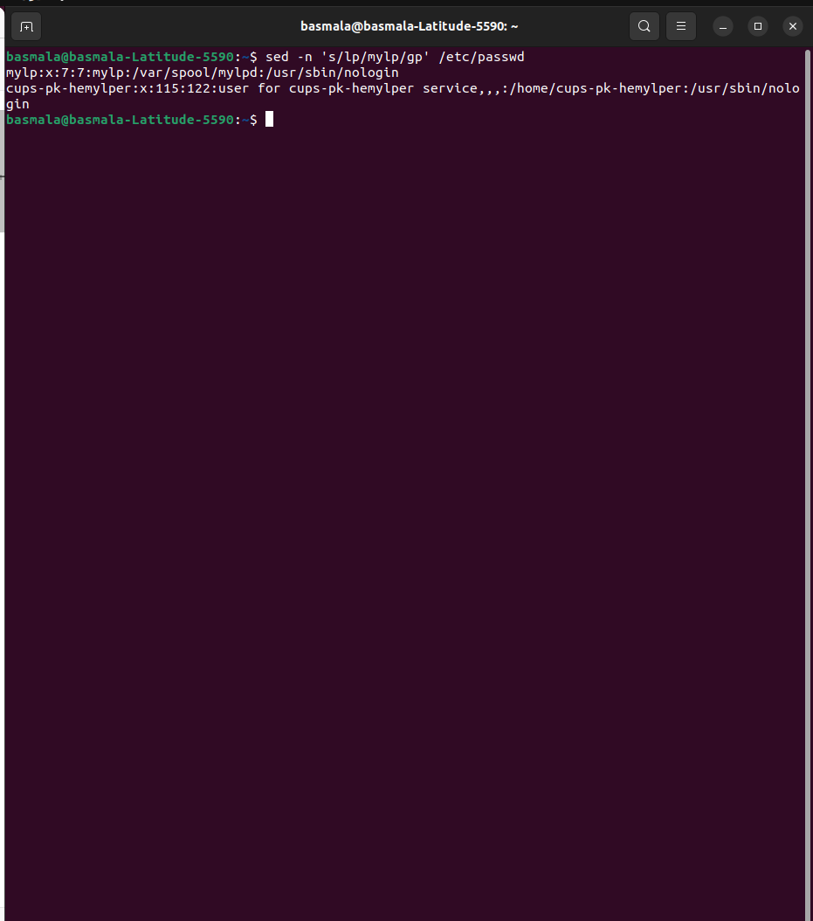

Using awk utility
1- Print full name (comment) of all users in the system.
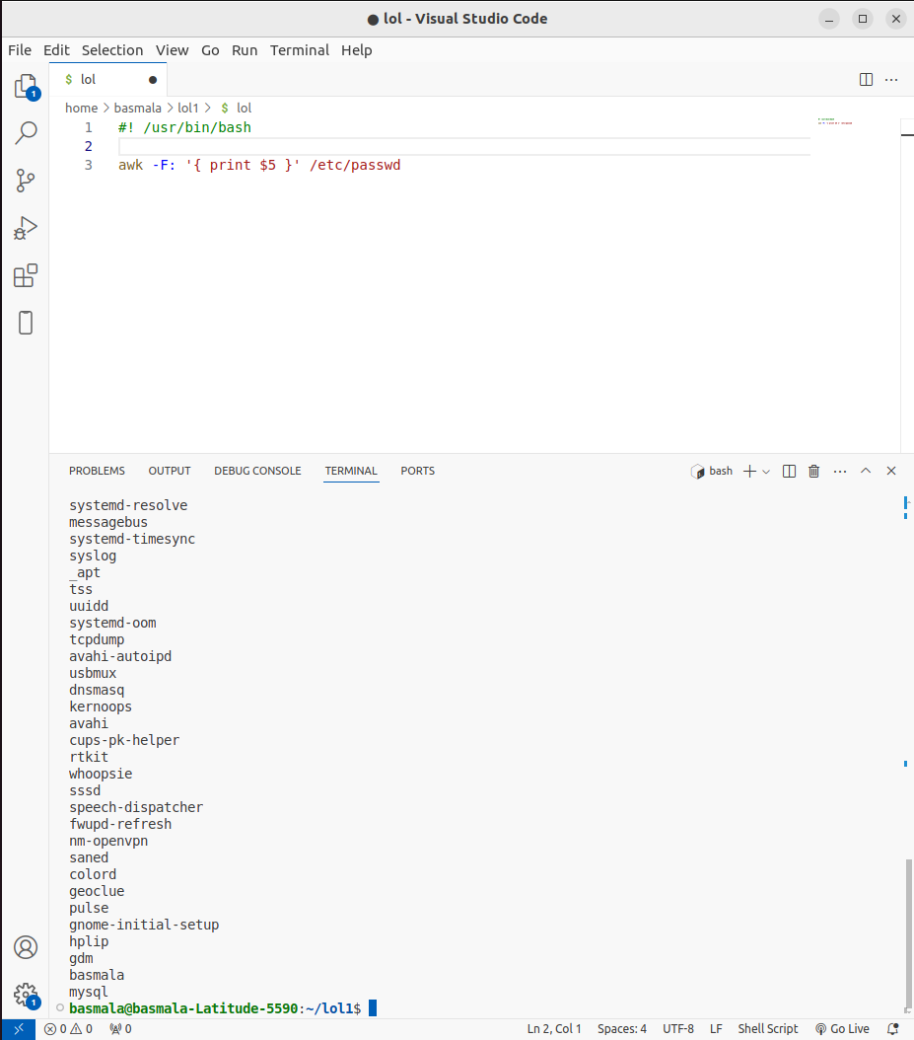
2- Print login, full name (comment) and home directory of all users.( Print each line preceded
by a line number)
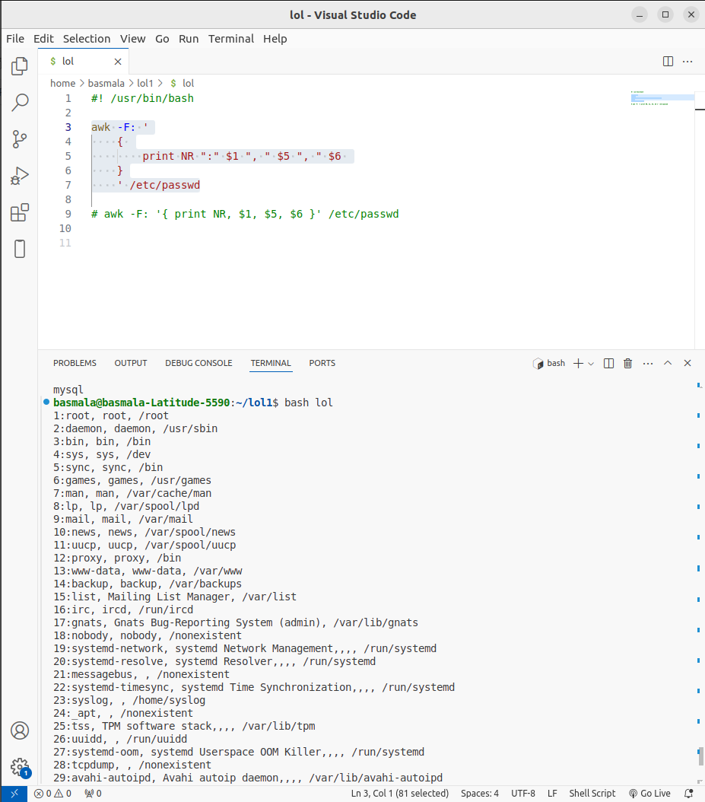
3- Print login, uid and full name (comment) of those uid is greater than 500
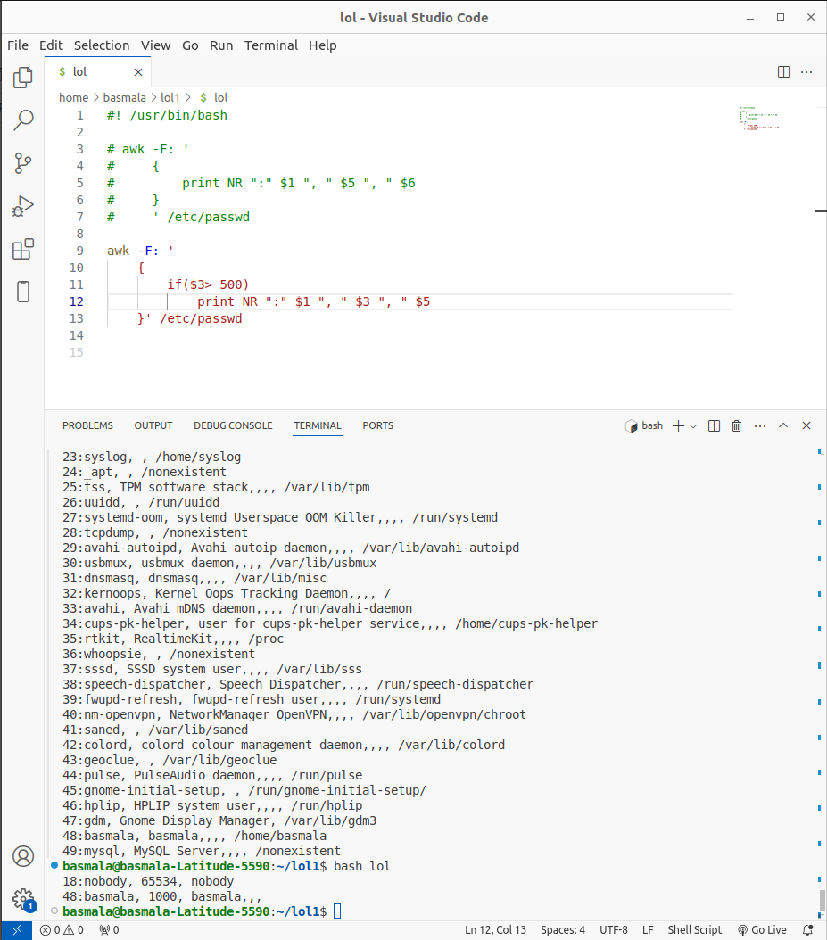
4- Print login, uid and full name (comment) of those uid is exactly 500
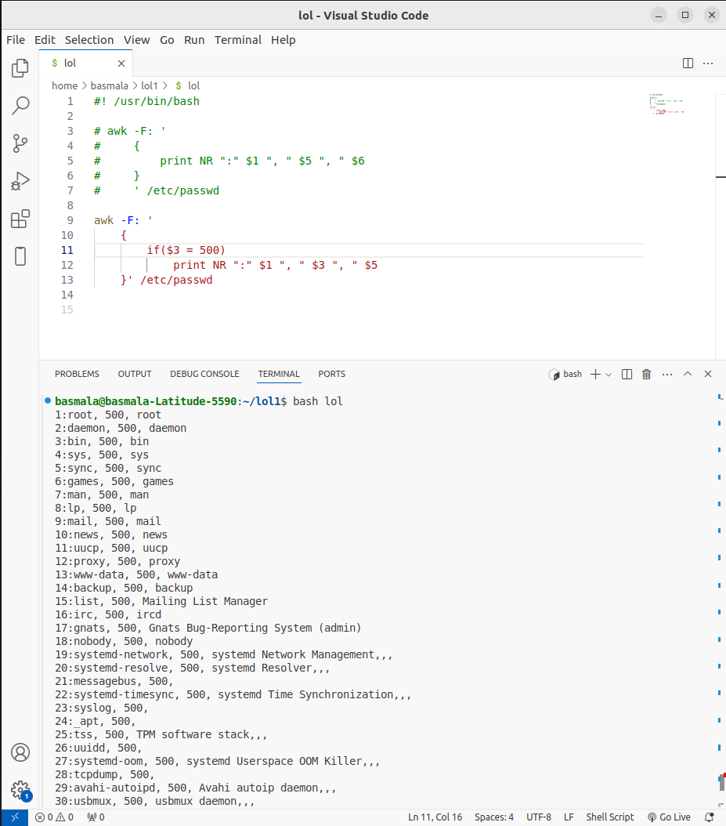
5- Print line from 5 to 15 from /etc/passwd
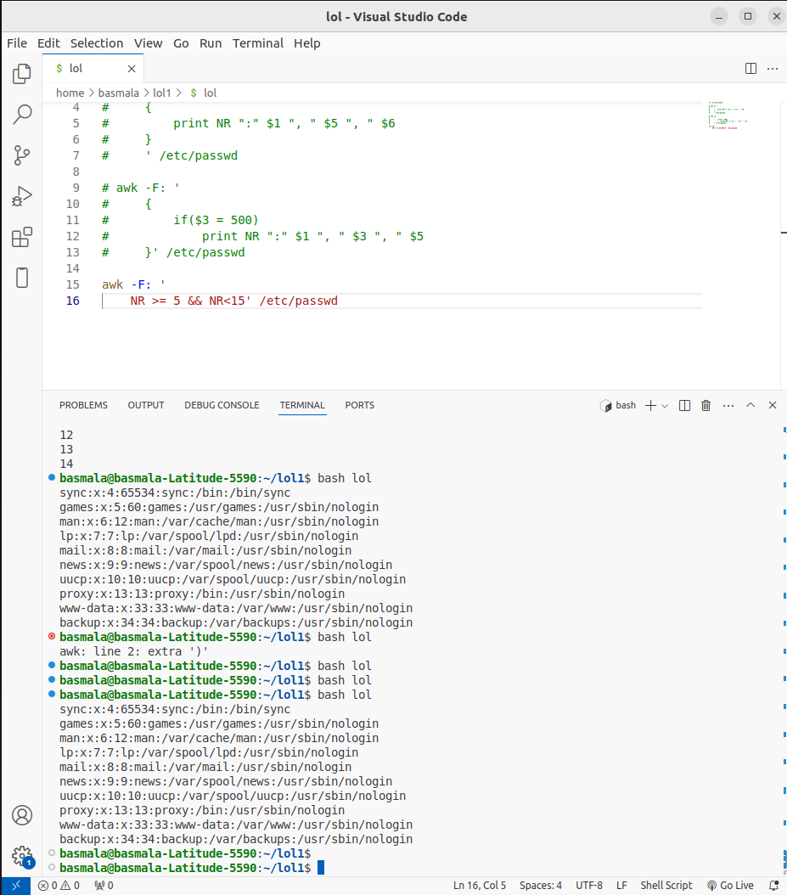
6- Change lp to mylp
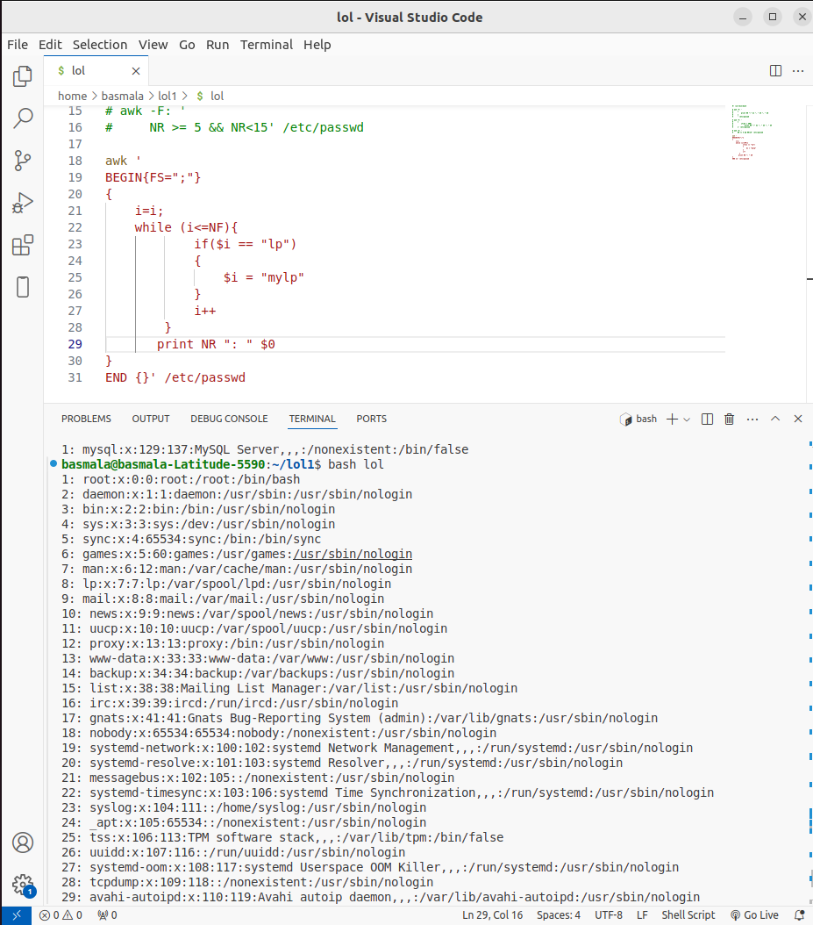

7- Print all information about greatest uid.

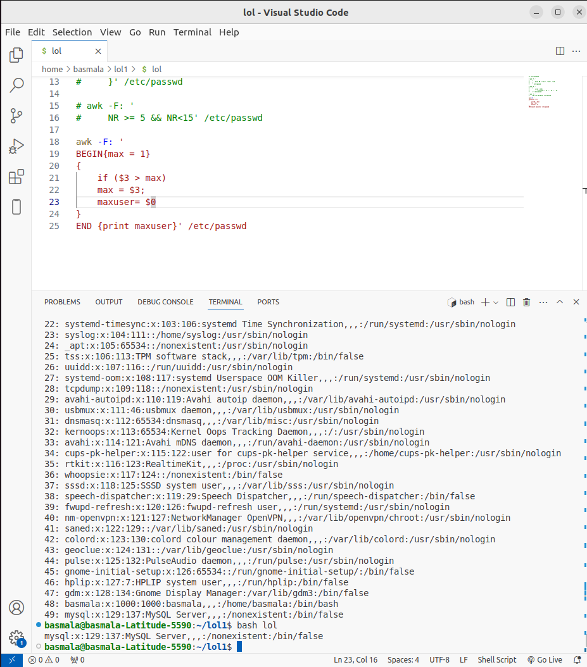

8- Get the sum of all accounts id’s.

